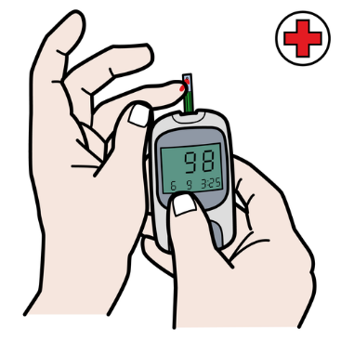
Diabetes Handout

Type of Medication | Day before Procedure | Day of Procedure
Insulin Pump | Use “sick day” or “sleep” rates | Use “sick day” or “sleep” rates
Insulin (long/intermediate acting) | Take 50% of your normal dose | Do not take
Short acting insulin | Take as normal | Do not take - please bring insulin with you to your appointment
Oral medication | Take morning dose  Do not take evening dose | Do not take

Continue to check your blood sugar throughout the prep process. Ideally keep blood sugar levels between 80-250. Please call your Procedure Coordinator, 510-444-3297, or a nurse at the center, 510-893-1600, if you have any questions.

